

AIR UNIVERSITY, AEROSPACE AND AVIATION
CAMPUS, KAMRA
DEPARTMENT OF COMPUTER SCIENCE

DIGITAL IMAGE PROCESSING LAB
BSCS – V

Name | MAIZA FATIMA
Registration ID | 235205
Semester | 6th
Date of Submission | 3rd April , 2026 Friday
Submitted To | Sir Ghulam
 | LAB TASK:06

Task No:01

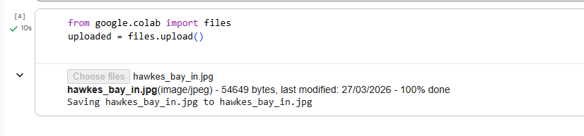
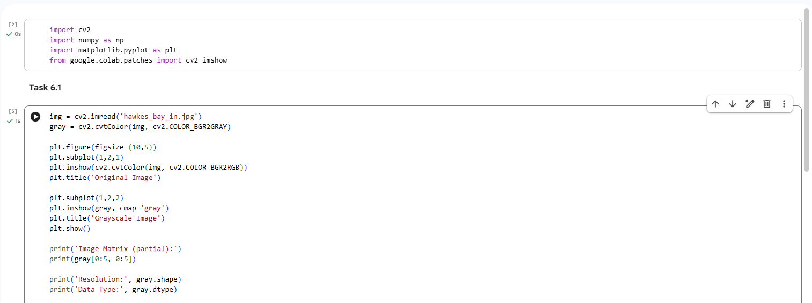
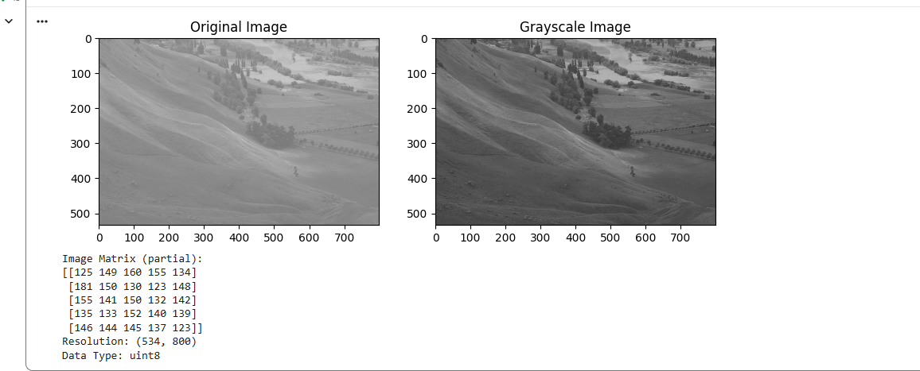

In this task, the image ‘hawkes_bay’ was loaded using the ‘cv2.imread()’ function. The image was converted into grayscale using ‘cv2.cvtColor()’. The original image and the grayscale image were displayed side by side. The image matrix, resolution, and data type were also printed in the console.

Task No: 02

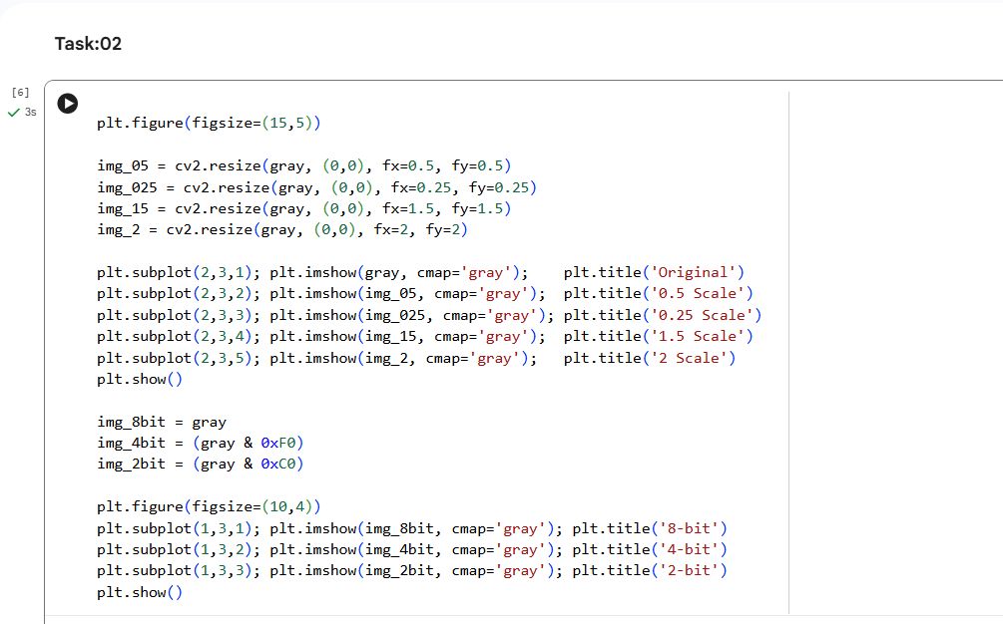
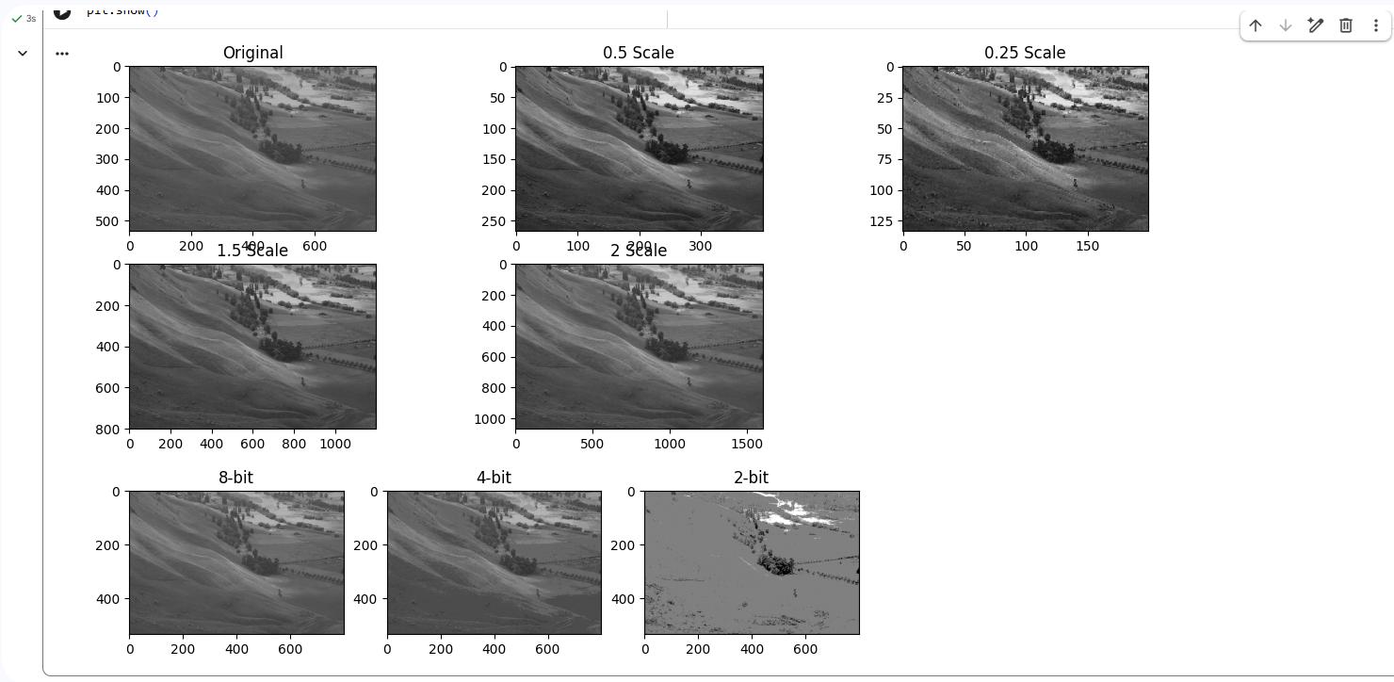
In this task, I have resized the image at different scales like 0.5, 0.25, 1.5, and 2 using the cv2.resize() function. In addition, I have reduced the bit depth to 8-bit, 4-bit, and 2-bit. I noticed that when the scale is reduced, the image becomes smaller. Moreover, when the bit depth is reduced, the quality of the image is reduced significantly.

Task No: 03

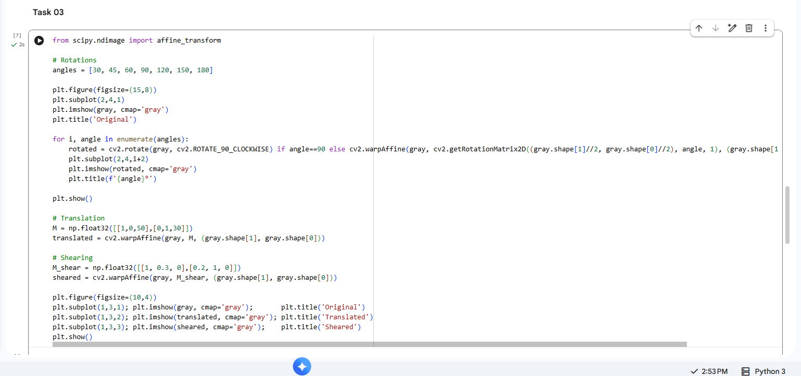
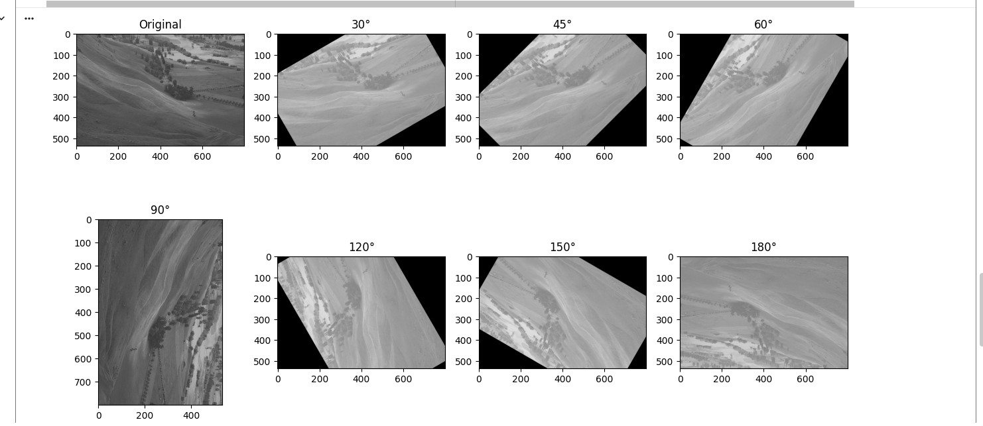
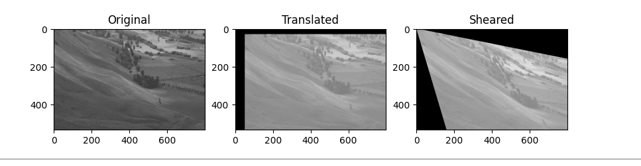
In this task, rotation was applied at seven different angles: 30, 45, 60, 90, 120, 150, and 180 degrees using the cv2.warpAffine() function. Translation and shearing were also applied to the image. It was noted that rotation changed the orientation of the image, translation changed the location of the image, and shearing changed the geometric orientation of the image.

Task No: 04
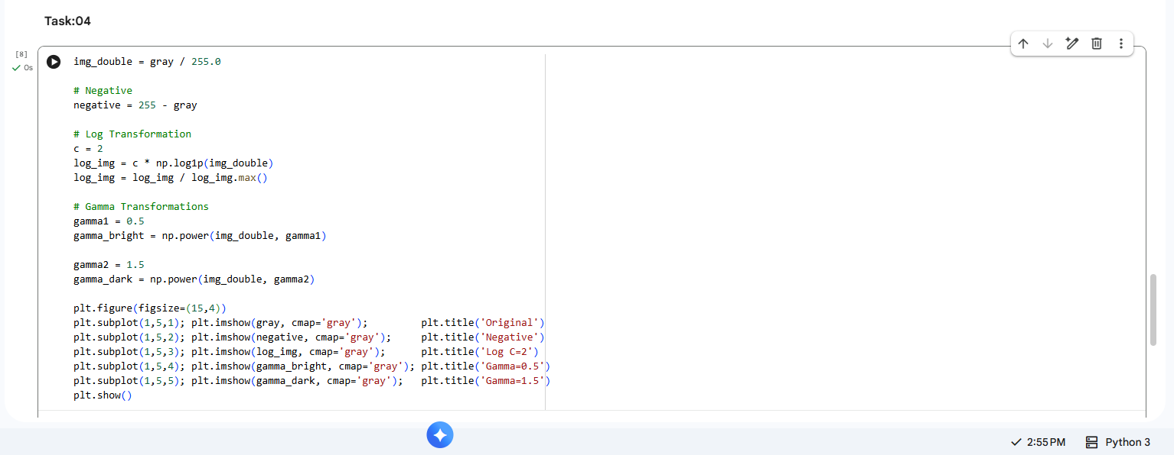
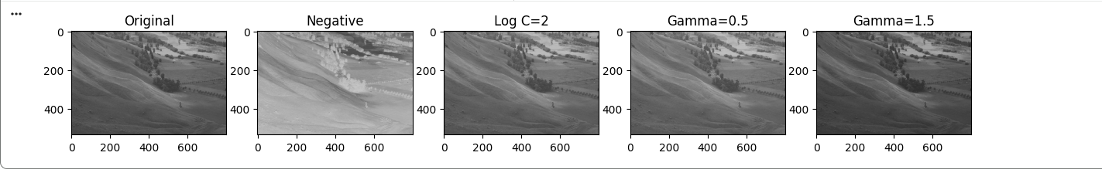
In this task, I used a negative transformation, log transformation with C = 2, and gamma transformation with values 0.5 and 1.5 on the grayscale image. I noticed that when I used a negative transformation, the pixel values were inverted. Log transformation made the dark regions brighter, while gamma 0.5 made the image brighter, and gamma 1.5 made the image darker.

Task No: 05
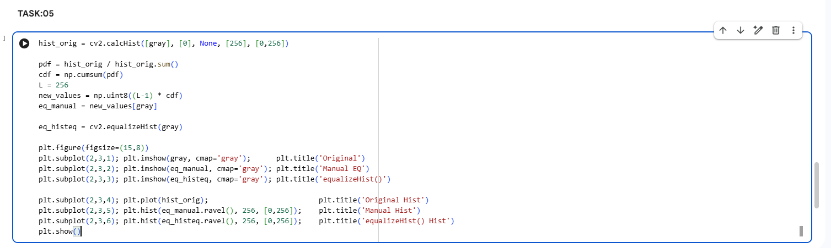
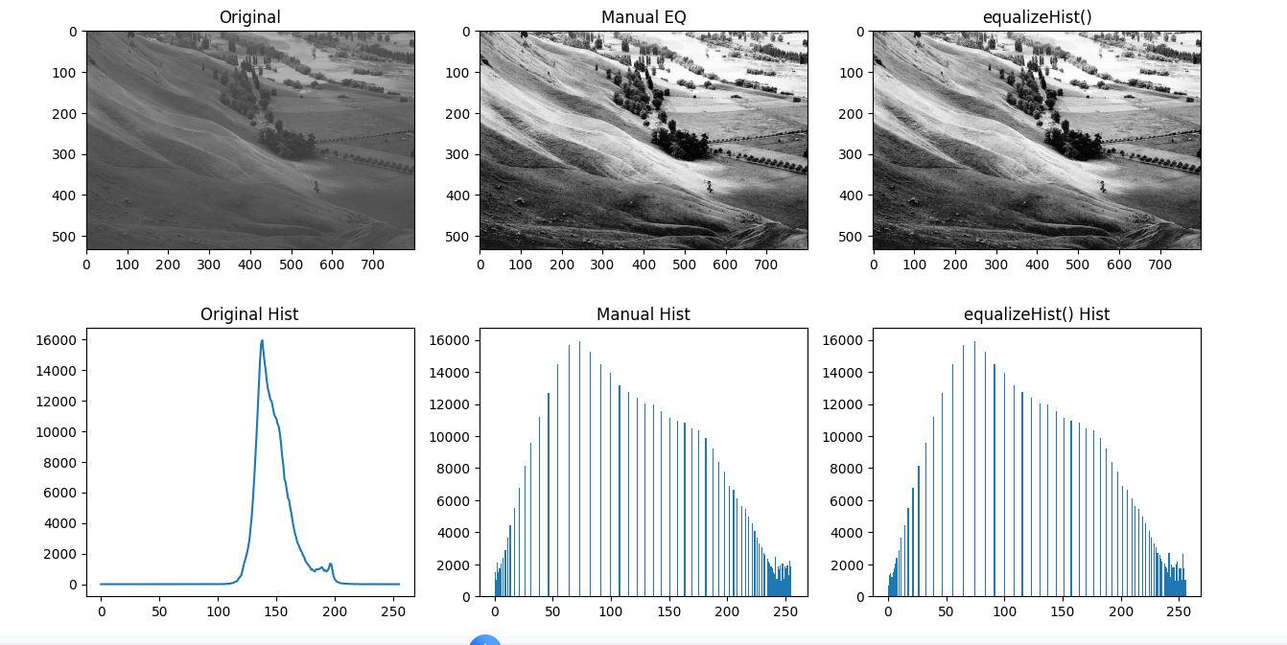

In this task, I plotted the histogram of the original image, equalized the histogram using manual methods with the PDF and CDF formulas, and used the OpenCV function equalizeHist(). I noticed that the original image histogram was only distributed over a narrow range, indicating a low contrast image. However, the histogram was distributed across the whole range after equalization.

Task No: 06

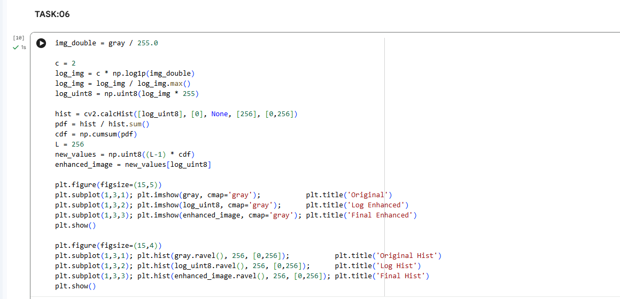
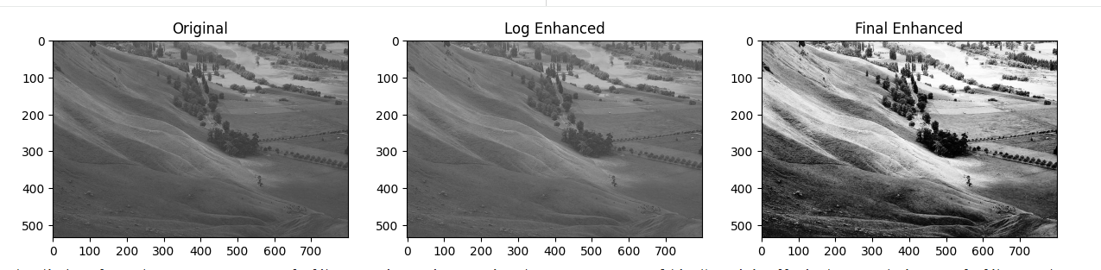
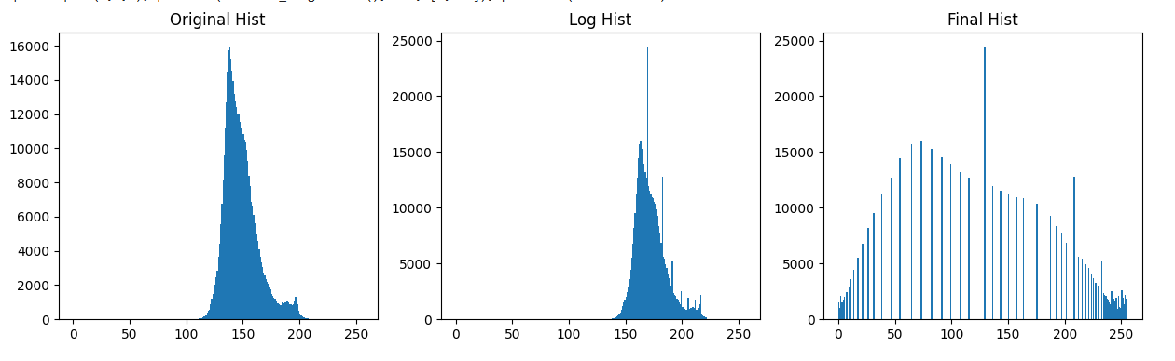
In this task, an entire image enhancement pipeline was created using a combination of log transformation and histogram equalization. Log transformation was applied first to enhance the dark areas of the image. After that, histogram equalization was applied to enhance the entire range of pixel intensities in the image. It was noted that the final enhanced image has better contrast compared to the original image.

